KALULA SECURITY LIMITED

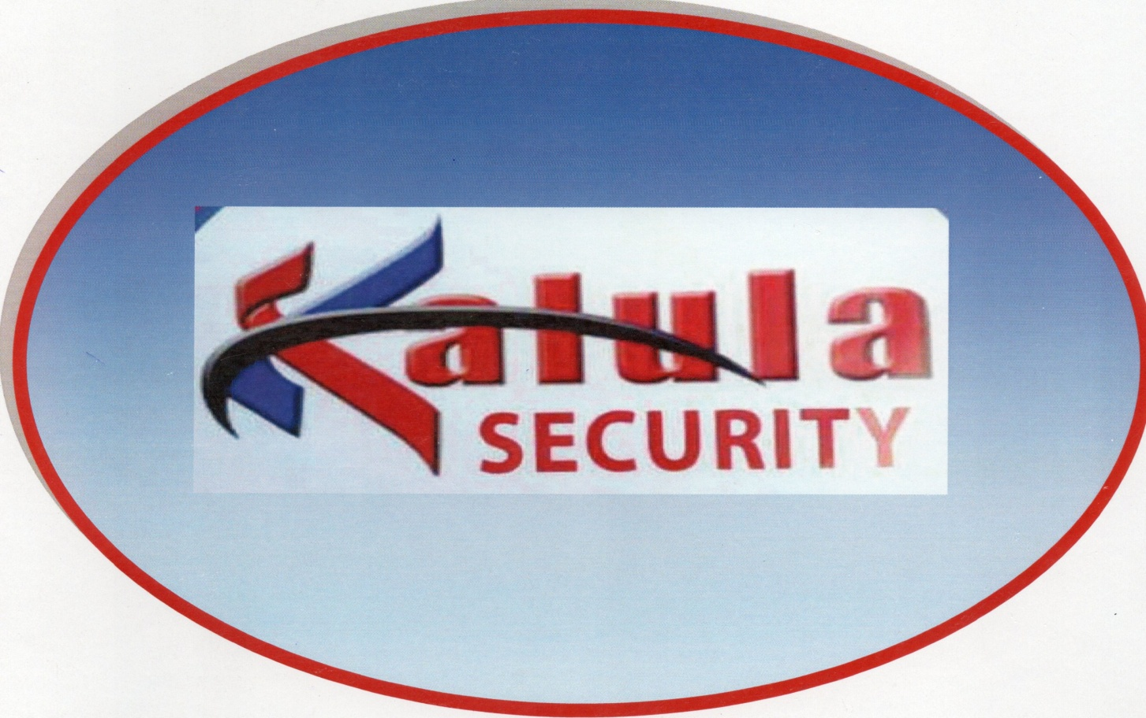

COMPANY PROFILE

Email: kalulaslimited@gmail.com Web:

WHO WE ARE

Kalula Security is a young Tanzanian based company incorporated under the laws of Tanzania. The management of Kalula Security includes a portrayal of well trained security personnel with a task force that has great experience and expertise in the security industry.

MISSION STATEMENT

Our mission at large is to provide the best and qualitative solutions to our customers by adhering to the following principles;

* Offer outstanding services at competitive rates for a wide range of security discipline, resulting in cost effective and comprehensive programs tailored to our customers’ needs.
* Retain, recruit encourage promotion from within; and to offer notable employee benefits.
* To be professional hands on Security Company, to provide on-site security services and creating a service catering to each client specific needs. We aim at exceeding our client’s expectations.

VISION STATEMENT

Our vision is to be the highest leading security company in the industry by giving out the best of services to the content of our customers.

OUR VALUES

* Integrity: absolute honest, integrity and fairness guide all actions.
* Teamwork : working together across departments
* Professionalism: living up to our commitments.
* Accountability: talking ownership of our behaviors, actions and results.
* Innovation: constantly seek better ways to do everything.

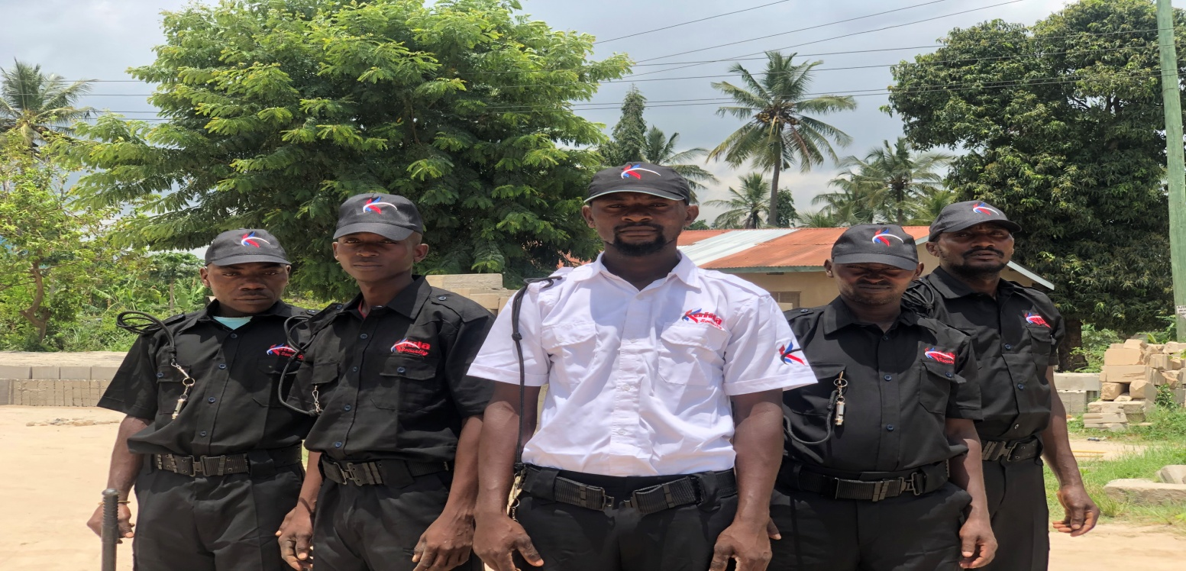

KALULA SECURITY OFFERS PROVISION

* Guard Services and Deployment
* Intruder Alarm Systems
* CCTV Surveillance Cameras
* Fire Detection System and Rescue
* Ambulance services and medical evacuation. Canine (K9) Unit
* Specialized Security Equipment
* Integrated Security Systems
* Access Control System (Biometric and card systems)

SECURITY SERVICES:

1. T he mission of the KALULA SECURITY is to safeguard life and property associated with operations, and to reduce the exposure to loss in order to increase profitability and positive international clientele support. In addition, KALULA SECURITY shall contribute to the overall social and community relations’ plans o the client where necessary within the local environs.
2. The concept will run the security around management team whose primary responsibility will be turn information into real time intelligence, leading o the flexible and timely deployment of the force to meet extant and upcoming threats.
3. The KALULA SECURITY field officer shall report by exception to the General Manager or his designated appointment, whenever sensitive or urgent issues arise. For all other occasions the KALULA SECURITY field officer will also maintain a functional reporting line to KALULA SECURITY Management in Dar es Salaam.





SCOPE OF WORK

* To provide competent and professional 24-hours Security Guard services at the posts listed above.
* To provide covert security forces if so required as additional security options during VIP and high profile visits and functions.
* To prevent the entry of unauthorized personnel and vehicles into or in the office plant.
* To physically search all staff exiting the goods/staff entrance.
* To conduct dedicated goods verification on receipt of supplies Via Local Purchase Orders, Delivery Notes, Goods Received Notes and or Dispatch/Returns leaving premises as per client requirement.
* To prevent damage to client and visitors property (To exclude accidental damage, etc).

KALULA SECURITY DOG SECURITY

Kalula Security dog teams are more of a deterrent and cost effective with incredible sense of hearing and a powerful sense of smell. This enables them to detect disturbance from a long distance, trained security patrol dogs are a valuable asset and ensure your security is not compromised.

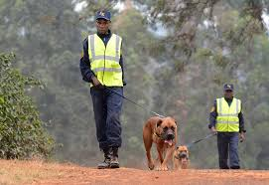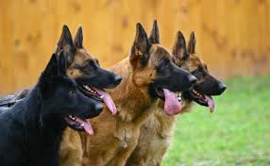

INTRUDER ALARM SYSTEMS (IDS)

Intruder alarms are not only the members’ one solution of preventing attacks on your property but also the means of protecting your possessions and the occupants too. KALULA SECURITY will supply alarm systems that are simple, user-friendly, effective and reliable so as to protect your business and your home.

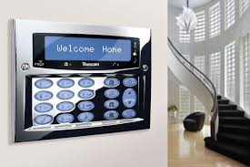

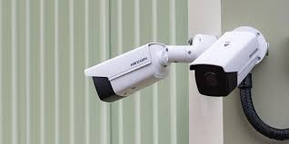

CCTV SURVEILLANCE CAMERAS

KALULA SECURITY will provide top of the range CCTV monitoring systems and provide regular servicing. Trained technical will be able to install off site monitoring services.

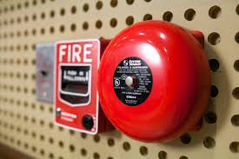

FIRE DETECTION SYSTEM AND RESCUE

KALULA SECURITY will provide a reliable service using our partners where we will reach our customers wherever they will be. Experienced medics will be on hand to ensure that the patients are evacuated should there be a need.

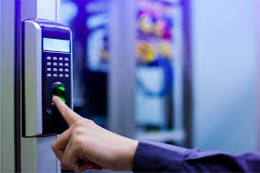

ACCESS CONTROL SYSTEM (BIOMETRIC AND CARD SYSTEMS)

We believe, that your security must include the ability to control who enters, where and when. Access control systems provide range of technical solutions to maintain free flow of authorized people whilst denying entry to unwanted guests.

<p>A full range of access control system and biometric system is available ranging from a single door to any unlimited computer and network based system , which for your security , could be integrated with CCTV, Intruder Alarm systems, Intercom and Elevator Control System. </p>

<p> Our suppliers ensure the optimum blend of quality equipment, service and technical support. KALULA SECURITY has vast knowledge in design and service of Access Control System such as: Cardax, Lenel, Honeywell, CEM, Paxton, Janus, Salto, X-Plan, Progeny etc.</p>

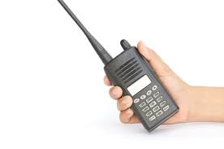

KALULA SECURITY GENERATION, RADIATION AND PROGRAMMING OF RADIOFREQUENCE OF RADIO CALLS SYSTEMS:

KALULA SECURITY generates and radiates radio frequency energy via installation and programming of radio calls systems.

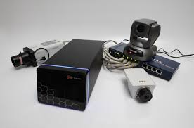

SPECIALIZED SECURITY/SURVAILLANCE EQUIPMENT

KALULA SECURITY provides professional service and high quality products that are tailored to clients needs. We represent reputable overused Manufacturers who supply Military and police equipment (systems) to the Tanzania Government.

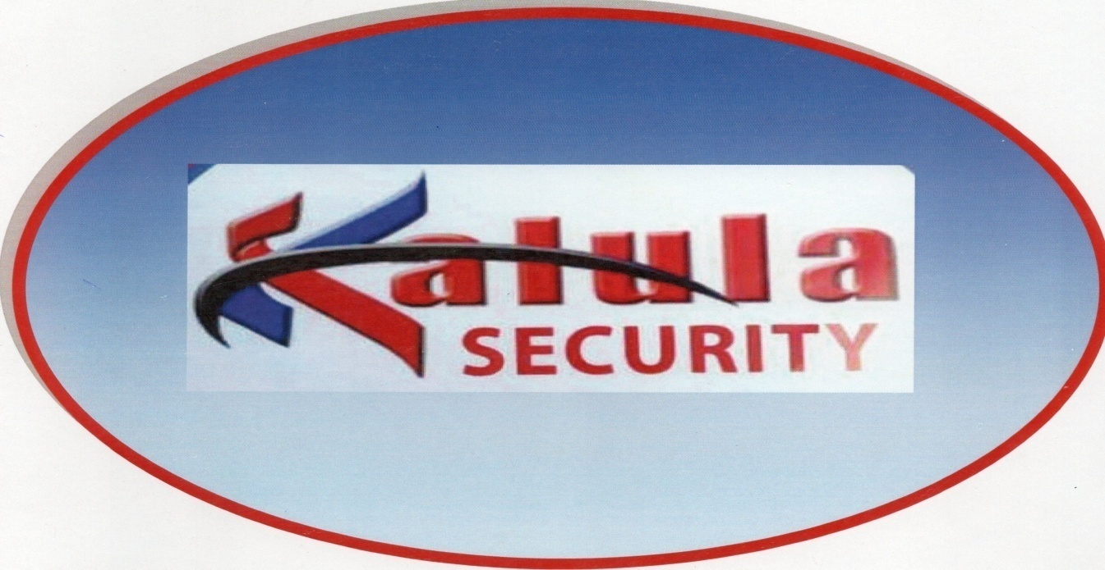

Our company believes in providing services and products that meet safety demand. We are flexible with our products and we do provide tailor made packages according to clients’ specifications.

CONTANT INFORMATION:

Name: Ms. Deborah.S.Lusajo

Email: [dlangborn@icloud.com](mailto:dlangborn@icloud.com)

Tel no: +255783636797

Name: Mr. Henry Mwakipunda

Email: [mwakipundahenry@gmail.com](mailto:mwakipundahenry@gmail.com)

Tel no: +255744946426